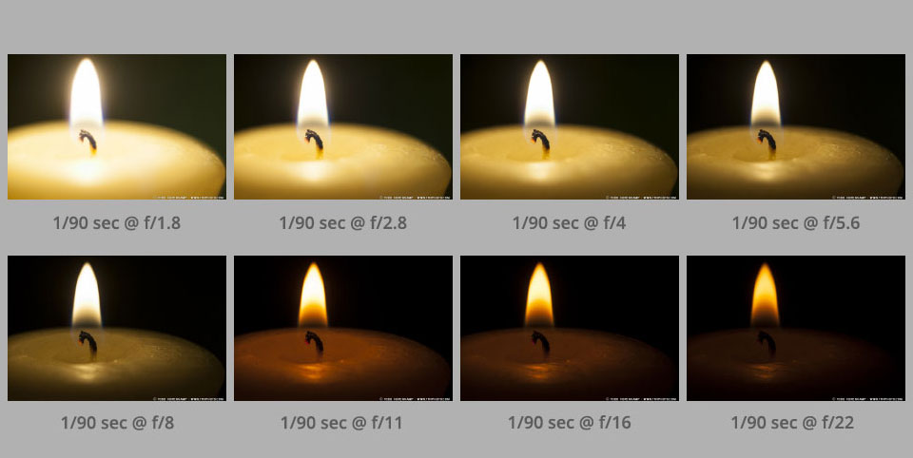

5 Photograph Series

- Create a Series of 5 photographs of the same composition, but use different aperture/ shutter speed settings for each.

Photography
- Find a subject- using a tripod or freehand, take a series of photographs of your subject with different aperture/shutter speed settings. Try and keep composition the same.
- Be sure to record what the settings are/ or in display mode press up on the direction pad and camera will display details.

Photoshop
- Open Photoshop.
- Go to File- Open a new document.
Size: H: 11in W: 8.5in Res: 300
- Place your photos into your Photoshop document. Compose image in an aesthetic manner.
- Using the text tool include for each:
-Aperture (f stop)
- Shutter Speed

Feel free to compose the final composition how you like. Style Points!

Criteria:
 | 1 mark | 3 marks | 5 marks
Text | Only 1 piece of information. | Aperture and Shutter Speed. | Aperture and Shutter Speed. Is displayed in and artistic manner. (ie. Font, Text colour, composition)
Layers | Uses 1 layer. | Uses 2 layers. | Uses 3 or more layers. (includes text layer, images layer and background.)
Photography | Photos are all similar in aperture and shutter speed. | The difference between shutter speed and aperture only cover half the spectrum. | The full extent of possible aperture and shutter speed are explored.
Work Habits | Student is not on task. | Student is sometimes on task. | The majority of time student is on task.

/20

